PowerSchool Information
Parents have the option to create their own Parent Portal Account that links all of their students together in PowerSchool for ease of access to Academic, Attendance, and Food Service Information. You are also able to access your SchoolMessenger account from PowerSchool to make any modifications to how you are notified.
PowerSchool is an easy to use, web-based student information system. It is intended to provide parents and teachers with a tool to communicate student performance. Powerschool may be accessed from any place the parent/guardian can access the Internet. The application is a secure link that encrypts the data to and from the end user. In addition, a username and password are provided to allow access for only authorized users to the appropriate student record.

PowerSchool - Parent Portal Access
PowerSchool has introduced a new single sign-on for parents. This means that parents can have one login to access all of their children’s grades, attendance, and food service information in one place. Also, parents and guardians will no longer have to share logins as each parent or guardian can set up his or her own unique login and password.
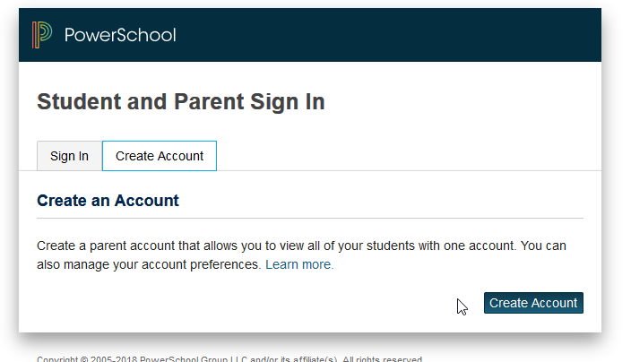
1. Go to “PowerSchoolt” from the Families drop-down on the school webpage (www.scfschools.com)

2. Choose “Create Account”

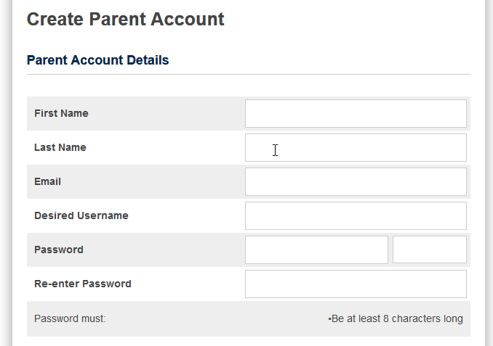
3. Fill in your information including new password, which must be at least 8 digits. This is not provided to you by the school.

4. Enter the Guardian user id & password that was provided to you for your child's school to link their information to your parent/guardian account

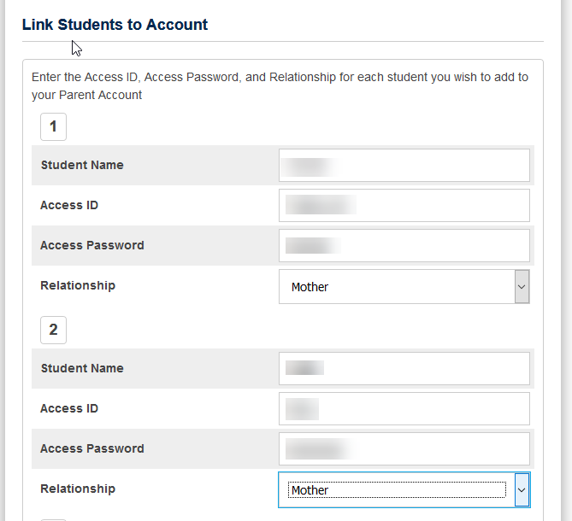
Once you have set up this new login, you can now manage your account by clicking the Account Preferences button.

If you have more than one student, you will see buttons to switch between your
students’ information.

If you have more than one student, you will see buttons to switch between your students’ information.

